WOODLANDS

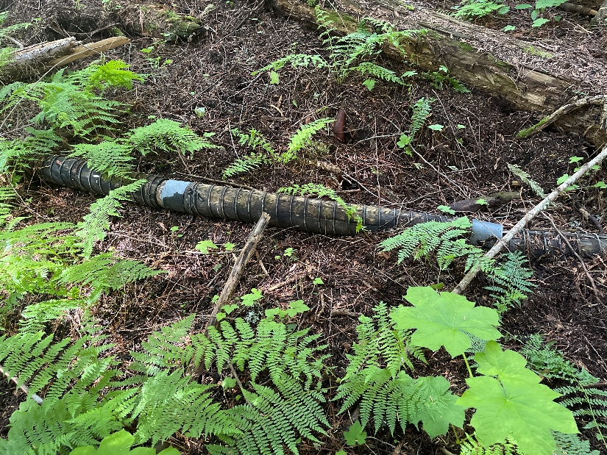
Timber development is finished in the True Blue area for now with a total harvest area of approximately 15ha or 5000m3. This area is popular for recreation and other non-timber values such as mushroom picking. A field tour was held with a few folks from the mushroom harvesting community to ensure our blocks don’t encroach on high value picking areas. Preliminary talks have been had with the mountain bike club and once the final maps are ready we will discuss the plans.

Some interesting history with some old water lines and intakes.
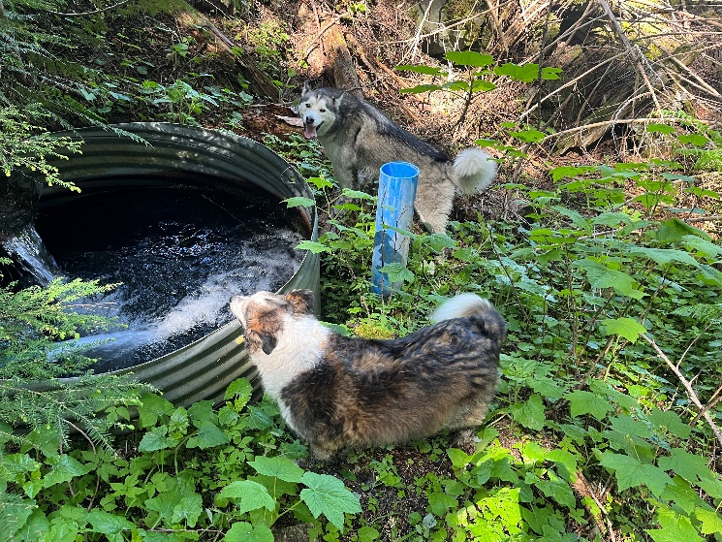

Due to the existing road that leads from the True Blue area towards the north side of Bjerkness Creek requiring fairly extensive upgrades for hauling the block in that area has been dropped for now and will be part of a larger development.

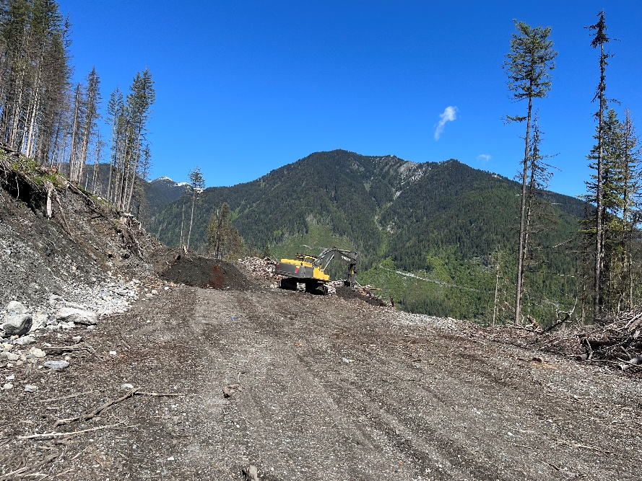
Sunshine completed the CP 52-1 road rehab work. Drone shot below of the recontoured road.

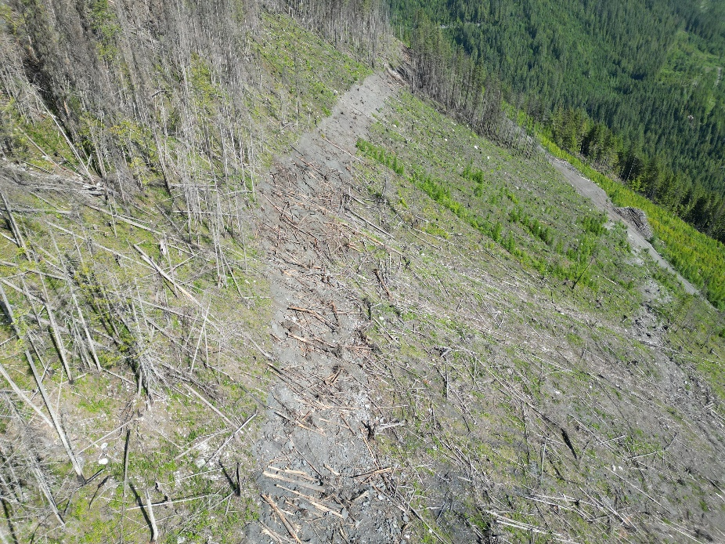

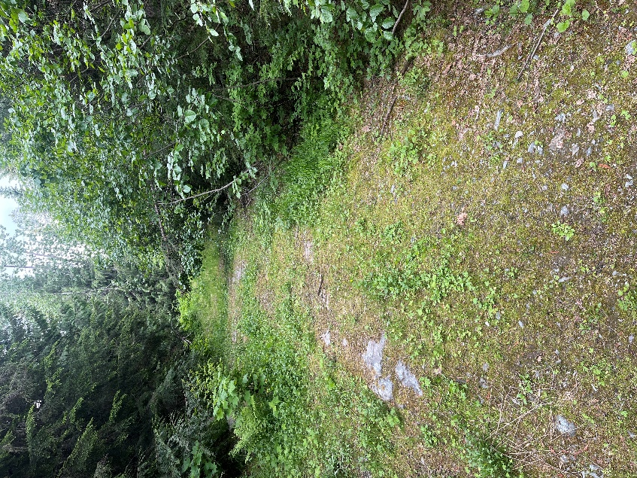
Sunshine started on the Lost Ledge road upgrades this week. To the north of Lost Ledge Creek the road will be upgraded by ripping brush in the right of way, ditching, installing culverts and stabilizing the road prism. Budget depending the road that leads left, or up, north of the bridge will be brushed for access, as well as the purple section of road leading south towards Schroeder Creek. Pic shows current road condition of the section we are upgrading. See map in folder for road sections to be upgraded and brushed in 2025.

The long wildfire planning block between Lost Ledge campground and Lardeau is almost complete and we will have some maps shortly.

SAFETY

No safety incidents from WRR, planting or timber development.

SILVICULTURE

Tree planting is complete for the season. It was great working with local planters Wes and Chett Mooney who did an awesome job.
Craig is conducting silviculture survey across our license, including regen, free to grow, and walkthroughs of blocks to plan activities in order for the stand to achieve free to grow status.
RESULTS reporting and waste survey plans for 2024 and 2025 harvesting are underway.

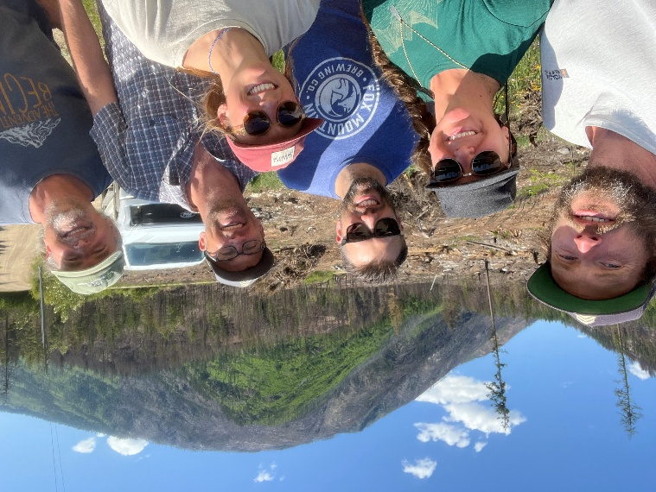
INTERNAL

The District has referred the Forest Stewardship Plan to First Nations.

SiFCO hosted the annual southern 6 CFA get together earlier in June to discuss community forestry and tour the 2024 fires and how they interacted with their fuel treatments. While we can conduct fuel treatments and all the planning we want, ultimately fire behaviour is determined by weather and topography. It was interesting to see different areas, with a manual thin from below treatment reducing fire behaviour more than a type 2 (leaving trees with 12m spacing) in one area, while the opposite was true in another area. The picture is taken from the end of a road where there are multiple houses. The fuel treatment enabled BCWS crews to access the area safely and save the homes.

WILDFIRE RISK REDUCTION

Craig and crew were working up in KAS6 along the Mt Buchanan Access Trail over the past few months. Due to the bush being dry no burning took place, instead piling debris to be burned at first snow. The KAS6 project has a bit of funding left so we are looking at potential areas to treat.

A joint field tour with BCTS and BCWS was held in June to discuss landscape level fuel breaks and what that could look like across KDCFS and BCTS tenure, which share the Mt Buchanan – 7 Mile area. A few potential treatment units were IDd and some field work will be conducted over the summer with a fall meeting scheduled to discuss outcomes and a path forward.

