WOODLANDS

Numerous trees and a small landslide were blocking Keen Creek. The road was opened by Marsh Hawes so planting could start this week. Locals were also keen to get up there to carry on with recreational activities.

Timber development up Cooper Face and Lost Ledge is complete and the permits have been applied for. It is anticipated we will receive the permits in the next few weeks. Harvesting of CP 50 up Cooper Face will start sometime in June and will be done by Timber Ridge.

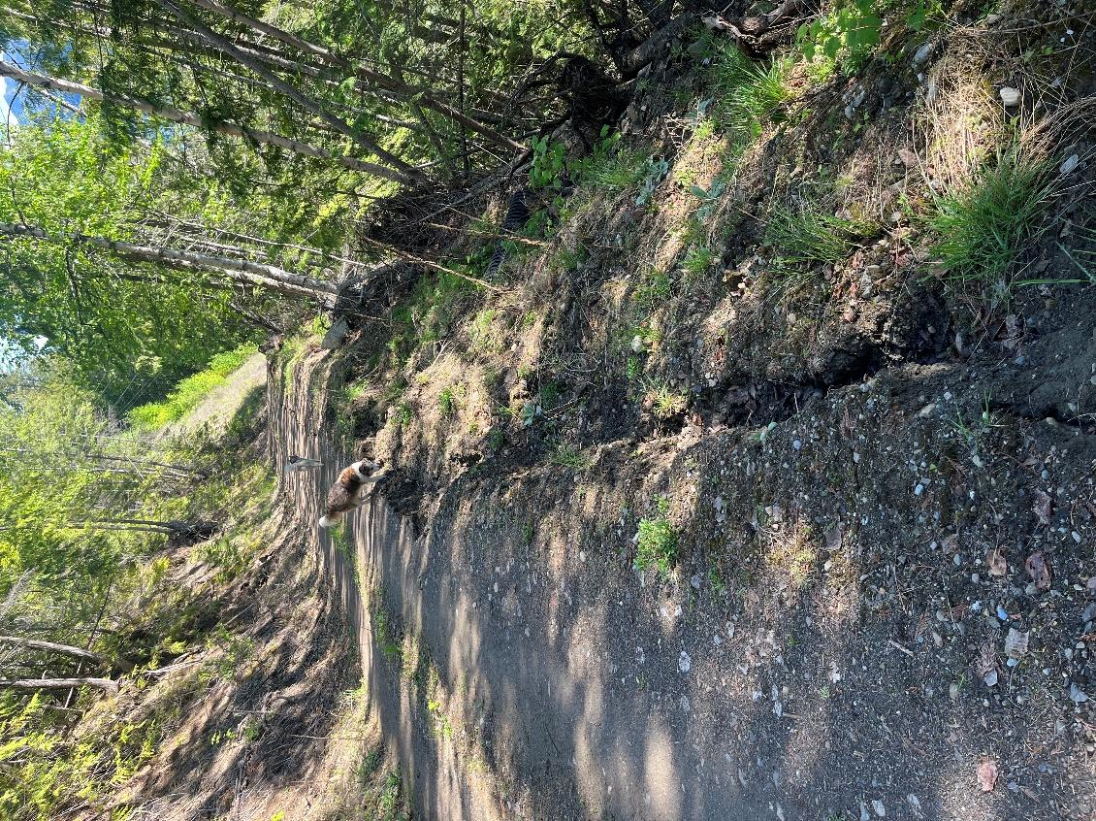
Near the bottom of the Lost Ledge road, the fill slope is slumping away and needs to be repaired.

Also, there are a few sections of the existing road that need to be rerouted as they are too steep for hauling. These sections, around 1km total, will be constructed once the permits are received, with harvesting of CP 57 commencing shortly after. The road brushing program will continue up Lost Ledge as well, brushing out 5-10kms of old road for access. Work will be done by Sunshine Logging.

The Keen Creek salvage logging required multiple trails and yarder spurs on steep ground that need to be rehabbed, along with some general road maintenance activities. Once the snow melts the work will be completed by Marsh Hawes.

CP 56, the block behind the dump that was harvested this winter, was littered in post harvest debris. Post harvest clean up work, along with trail rehab, is currently being done by Marsh Hawes.

SAFETY

No safety incidents from WRR work, tree planting, or timber development.

SILVICULTURE

Tree planting started this week up Keen Creek, with the work being done by local Wes Mooney. The trees are being stored frozen in a reefer trailer at the arena. A big thanks to the arena Board for allowing us to use this site as it is in the shade and easy access for the planters.

Review of the 2025 surveys is ongoing, along with free growing and regen declarations in RESULTS. 10 blocks will be declared free growing from our recent surveys, with 9 more blocks scheduled for free growing surveys this year. After this most of our legacy blocks will have achieved free growing status.
A silviculture tracker spreadsheet has been developed to show the blocks, whether they have achieved free growing or regen declarations, and what needs to be input into RESULTS. See folder in Sync.

Walkthrough surveys of several blocks will determine if brushing treatments are needed this year.

INTERNAL

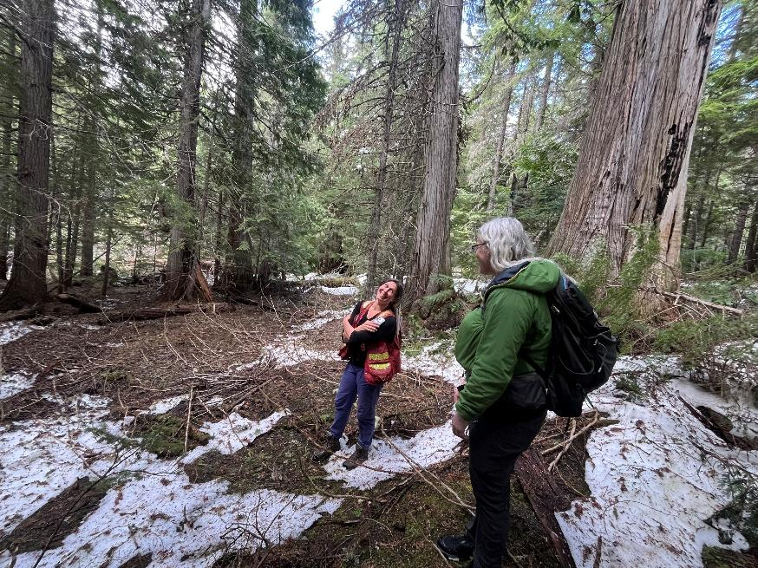
The manager will be attending the BCCFA conference in Vernon the first week of June.

Deb MacKillop, Forest Biodiversity Lead, and Julie MacDougall, Executive Director, both from the Office of the Chief Forester, came for a field tour this week up Cooper Face to discuss old growth, biodiversity, forest economics, and a path forward for forestry in BC. Good talks about local manufacturing capacity, doing more with pulp through bioenergy, biochar, or finding new markets for niche products made from small diameter timber, and how the province should be the driver behind it.

WILDFIRE RISK REDUCTION

The manual treatment in CP 55 above Lardeau is complete for now, with pile burning scheduled for fall or early winter when snow is on the ground.

FESBC just announced an intake for WRR projects that span from June 1, 2026 to March 31, 2027.
An application will be submitted for the manual implementation of KAS3, the area of unallocated Crown land around No Brakes that Cathro completed an FMP for in 2025.

